PD Session 7: Cooperative Learning and Classroom Management Issues Related to CBL Units
Speaker: Tim Dugan, Resource Teacher for CEEMS Grant at the University of Cincinnati
Date: June 28, 2017
Time: 10:30am-12:00pm
Venue: University of Cincinnati, Swift Hall, Room 516
Prepared by:
Kimberly Lykens, Stebbins High School, Dayton, Ohio
RET Participant for Project #1: “Synthesis and Characterization on Different Forms of Cu Nanoparticles to Mitigate Cu Leaching to Water Bodies”

This professional development workshop on cooperative learning and classroom management related to challenge-based learning (CBL) was given by Tim Dugan, a resource teacher for the CEEMS grant at the University of Cincinnati. Mr. Dugan is also a consultant on school improvement, taught social studies for 28 years, and has received several accolades for his incorporation of technology in the classroom. Mr. Dugan has experience with higher-education as an adjunct instructor of courses such as Educational Technology for Teachers, Intermediate and Advanced Social Students Methods, and Classroom Management. This professional development session was held on June 28, 2017 from 10:30pm-12:00pm at the University of Cincinnati in Swift Hall (room 516).

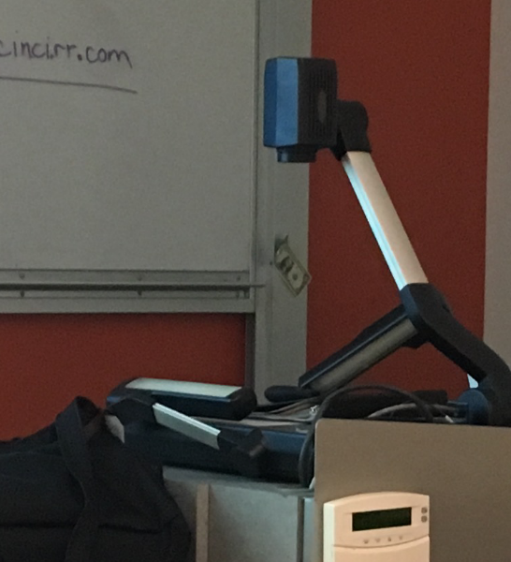
Mr. Dugan began his session by passing out two notecards and asking each RET participant to put names of two other RET participants he or she would like to work with throughout the workshop. He then asked the audience to elaborate upon the purpose of this activity and the RET participant that volunteered an answer received a one-dollar bill from Mr. Dugan. Other one-dollar bills were displayed in the classroom as a strategy to encourage participation from the audience (Figure 1).

The goals and objectives of Mr. Dugan’s workshop included teachers being able to a) recognize the benefits and challenges of collaboration, b) evaluate differences between competitive and collaborative lessons, c) list best practices for collaboration, and d) describe how teachers can use technology to encourage collaboration in CBL units (Figure 2). After stating the goals, Mr. Dugan reviewed work by John Hattie, one of Mr. Dugan’s favorite names in education pedagogy research. The focus of John Hattie’s work is to compile data from volumes of education research and statistically define the factors in education that make the most impact on student learning. Some factors that negatively influence student success are depression and mobility. Mr. Dugan shared a personal story about mobility and stated that students who move schools often are less likely to learn the material they need to be successful. Factors that positively influence student learning are collective teacher efficacy, teacher estimates of achievements, and self-reported grades. Mr. Dugan described teacher efficacy as teacher’s examining their own behaviors.
Figure 1. Mr. Dugan’s Dollar Bill Participation Strategy

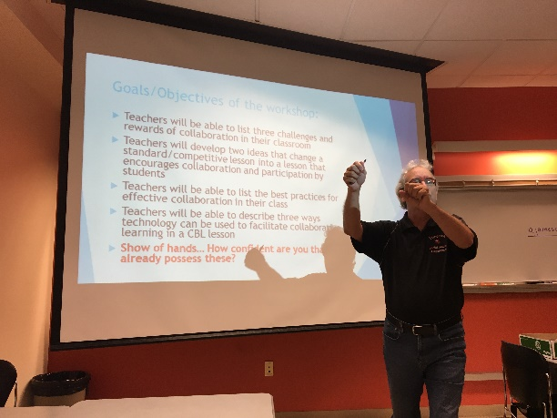
Mr. Dugan ended the background on learning portion of the workshop by reviewing the work of Jerome Kagen, an expert on cooperative learning. Kagen recommends the use of a sociograms when grouping students as an easy way to see the social dynamic of the classroom (Figure 3). Mr. Dugan made a sociogram for the RET participants using the notecards from the beginning of the workshop. Mr. Dugan ended his background of learning by sharing a personal story from military boot camp in which he experienced cooperative learning. He then asked RET participants to brainstorm and share a time in which a learning experience was competitive or collaborative.
Figure 2. Mr. Dugan explaining the goals and objectives.

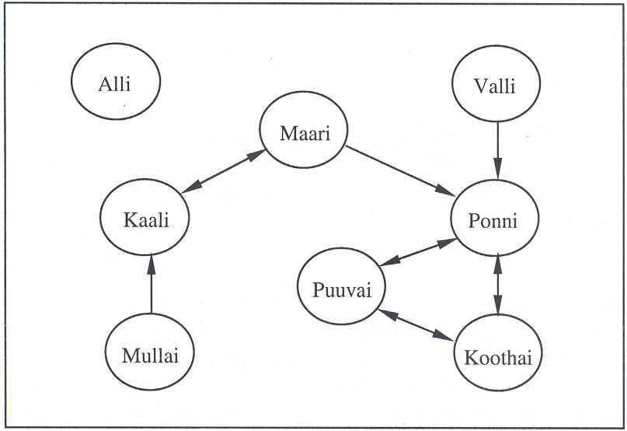
Mr. Dugan continued his presentation by discussing the types of collaboration, such as group presentations, debates, and large group engineering projects. He then shared a resource called Edutopia that contains vast amounts of resources on cooperative learning strategies for teachers. Mr. Dugan then asked the RET teachers to pick a lesson they have done in the past that was competitive and explain how they would change the lesson to be more collaborative using technology. Mr. Dugan spent a significant amount of time talking with each RET teacher about the lesson they chose and elaborating on their thoughts.
Figure 3. An Example of the Sociogram Mr. Dugan Created for the Workshop.

Mr. Dugan concluded his workshop by summarizing the key ideas he wished to convey to the RET teachers: a) CBL/PBL are better facilitated within student groups, b) technology should be a main focus of CBL/PBL, c) students prefer group work over individual work, and d) collaborative work facilitates real-world problem solving the best.

